“Construction Mobile App for Contractor Self-Service”
A Project Report Submitted in the partial fulfillment of the requirements for the award of the degree of
BACHELOR OF TECHNOLOGY
In
DEPARTMENT OF COMPUTER SCIENCE AND ENGINEERING
Course: Database Systems Engineering and Distributed Backend Development (25CS1302E)
Section 3 | Team No. 9 | 2026-27, ODD SEM
By
P. VENKATA SRI SAI MADHURIMA :2520030182
T. HASINI :2520030102
VISHAL :2520030521

Under the Esteemed Guidance of
Dr. Y. Subbarayudu
Assistant Professor
Department of Computer Science and Engineering



K L (Deemed to be) University
DEPARTMENT OF COMPUTER SCIENCE AND ENGINEERING

Declaration
The Project Report entitled “Construction Mobile App for Contractor Self-Service” is a record of Bonafide work of P. VENKATA SRI SAI MADHURIMA - 2520030182, T. HASINI - 2520030102, VISHAL - 2520030521 submitted in partial fulfillment for the award of B. Tech in Computer Science and Engineering to the K L University. The results embodied in this report have not been copied from any other departments/University/Institute.

P. VENKATA SRI SAI MADHURIMA – 2520030182
T. HASINI – 2520030102
VISHAL – 2520030521

K L (Deemed to be) University
DEPARTMENT OF COMPUTER SCIENCE AND ENGINEERING

CERTIFICATE
This is to certify that the project based report entitled “Construction Mobile App for Contractor Self-Service” is a bonafide work done and submitted by P. VENKATA SRI SAI MADHURIMA - 2520030182, T. HASINI - 2520030102, VISHAL - 2520030521 in partial fulfillment of the requirements for the award of the degree of BACHELOR OF TECHNOLOGY in Department of Computer Science and Engineering, K L (Deemed to be University), for the course Database Systems Engineering and Distributed Backend Development (25CS1302E), during the academic year 2026-2027.

Signature of the Guide

Signature of the Course Coordinator | Signature of the HOD

ACKNOWLEDGEMENT
The success of this project would not have been possible without the timely help and guidance rendered by many people. We wish to express our sincere thanks to all those who have assisted us in one way or the other in the completion of our project.
Our greatest appreciation goes to our guide, Dr. Y. Subbarayudu, Assistant Professor, Department of Computer Science and Engineering, whose tremendous support, encouragement and guidance for this project cannot be expressed in words.
We express our gratitude to the Head of the Department of Computer Science and Engineering for providing us with adequate facilities, ways and means by which we were able to complete this project for the course Database Systems Engineering and Distributed Backend Development.
We thank all the members of the teaching and non-teaching staff who have assisted us directly or indirectly in the successful completion of this project. Finally, we sincerely thank our parents, friends and classmates for their kind help and cooperation during our work.

P. VENKATA SRI SAI MADHURIMA – 2520030182
T. HASINI – 2520030102
VISHAL – 2520030521

Abstract
The Construction Mobile App for Contractor Self-Service is a smart digital solution designed to simplify and automate construction project management activities. The application enables contractors to independently manage project details, workforce information, material requests, task assignments, progress tracking, and communication through a mobile device. It provides real-time access to project data, helping contractors make faster decisions and improve operational efficiency.
The app offers features such as project scheduling, attendance monitoring, expense tracking, document sharing, work progress updates, and notification alerts. Contractors can submit reports, request approvals, monitor resource utilization, and track project milestones without depending on manual paperwork. The system also improves coordination among contractors, site engineers, suppliers, and project managers.
By digitizing construction workflows, the application reduces delays, minimizes errors, enhances transparency, and increases productivity. The proposed mobile app serves as a cost-effective and user-friendly platform that supports efficient project execution and better resource management in the construction industry.
The system is built with React Native for the mobile front end, Node.js with Express.js for the REST API back end, PostgreSQL for data storage, JWT for secure role-based access, and Docker for packaging and deployment. The work is divided into ten modules, shared among the three team members.

Index
S. No | Chapters | Topics | Page. no
Acknowledgement
Abstract
1 | Introduction | 1.1 Background of the project  1.2 Problem statement  1.3 Scope of the project  1.4 Objective(s)  1.5 Importance of the application  1.6 Target users/audience | 1-4
2 | System Requirements | 2.1 Hardware requirements  2.2 Software requirements  2.3 Development tools and frameworks | 5-6
3 | Technology Stack | 3.1 Front-end (React Native)  3.2 Back-end (Node.js with Express.js)  3.3 Database (PostgreSQL)  3.4 Version Control (Git, GitHub)  3.5 APIs or External services | 7-8
4 | System Architecture | 4.1 High-level architecture diagram  4.2 Description of each layer (frontend, backend, database)  4.3 Deployment architecture | 9-10
5 | Design | 5.1 ER Diagram  5.2 Database schema | 11-14
6 | Implementation | 6.1 Module-wise implementation  6.2 Front-end logic (UI rendering, state management)  6.3 API integration  6.4 Authentication & Authorization | 15-17
7 | Features | 7.1 List of main features  7.2 How each feature works (user perspective + technical description) | 18-19
8 | Testing | 8.1 Postman testing (frontend/backend)  8.2 Integration testing  8.3 Tools used for testing  8.4 Test cases and results | 20-21
9 | Deployment | 9.1 Steps to deploy  9.2 Environment configuration  9.3 Hosting of frontend and backend | 22
10 | Challenges & Limitations | 10.1 Issues faced during development  10.2 Solutions applied  10.3 Current limitations or known bugs | 23
11 | Future Enhancements | 11.1 Planned features  11.2 Possible integrations or optimizations | 24
12 | Conclusion | 12.1 Summary of the project  12.2 What was achieved  12.3 Skills learned during development | 25
13 | References | Books, tutorials, APIs, documentation sites used | 26
14 | Appendices | Screenshots of the app  Sample code snippets  Installation/setup instructions  User manual or guide  Geo Tag photos with guide  Review forms with guide signatures | 27-29

CHAPTER -1 INTRODUCTION

1.1 Background of the Project
The construction industry depends on the smooth coordination of many people and resources: contractors, site engineers, suppliers, project managers, workers, materials and daily tasks. Managing all of these efficiently is a constant challenge. Traditionally, contractor management has relied on paperwork, phone calls and manual reporting, which often leads to delays and communication gaps between the people who plan the work and the people who carry it out.
The rapid growth of mobile devices offers a practical way to remove these gaps. A contractor is usually on the move between sites, and a smartphone is the one device that is always available. A mobile-based self-service application allows contractors to manage tasks, submit reports, track progress and communicate in real time, without waiting for paperwork to travel between the site and the office.
This project, the Construction Mobile App for Contractor Self-Service, is built around that idea. It enables contractors to independently manage project details, workforce information, material requests, task assignments, progress tracking and communication from a mobile device. The project is carried out for the course Database Systems Engineering and Distributed Backend Development and therefore places strong emphasis on a well-organised relational database, a REST API back end, secure authentication and containerised deployment.
Existing system
Before the proposed system, construction project activities are handled in the following way:
- Contractor management is mostly handled through manual records and paperwork.
- Project updates are communicated through phone calls, emails, or physical meetings.
- Tracking labour attendance, material requests, and work progress is time-consuming.
- Lack of centralised data leads to miscommunication and project delays.
- Monitoring project status and generating reports require significant manual effort.
Technical foundation
The background of the project lies in combining the following areas of computer science:
- Mobile application development: a cross-platform mobile interface built with React Native.
- Database management: storage and retrieval of users, projects, workers, tasks, materials and reports in PostgreSQL.
- Backend development: REST APIs and server-side logic using Node.js with Express.js.
- Security: JWT-based login and role-based access so that only authorised users can use the application.
- Deployment: packaging and running the application consistently with Docker.

1.2 Problem Statement
Construction projects involve many parallel activities, yet the information about them is scattered across paper records, phone calls and emails. Contractors have no single place where they can see their projects, update their work, request materials and report progress. As a result, two core problems arise:
- Delayed communication between contractors and project managers.
- Difficulty in tracking project progress and resource utilisation.
Because there is no centralised data, a material request may wait for days for an approval, attendance records may be incomplete, and project managers may not know the true status of a task until a meeting or a phone call takes place. This causes delays, errors and wastage of resources.
Proposed solution (contribution)
The project proposes a mobile app that provides contractor self-service functionality. The solution:
- Enables real-time project progress tracking and reporting.
- Allows contractors to submit material requests and approvals digitally.
- Provides attendance and workforce management features.
- Generates automated reports and notifications.
- Improves communication between contractors, engineers, and project managers.
- Reduces paperwork, saves time, and increases project efficiency.

1.3 Scope of the Project
The scope of the project covers the design and development of a mobile application together with the back-end services that support it. The system is organised into ten modules:
No. | Module | Scope covered
1 | Contractor & User Management | Registration, login, profiles and user roles
2 | Project Management | Viewing and managing assigned projects, project details, deadlines and status
3 | Task & Work Management | Viewing assigned tasks, updating task status and recording completed work
4 | Workforce & Attendance Management | Worker details and attendance records across projects
5 | Material Management | Checking available materials and submitting and tracking material requests
6 | Progress & Report Management | Daily work updates, project progress and reports
7 | Notification & Approval | Notifications for task updates, material requests, approvals and project activities
8 | Database Management | Organised storage of users, projects, workers, tasks, materials and reports
9 | Backend API Module | Connecting the app to the database; requests, data processing and authentication
10 | Deployment & Monitoring | Docker-based deployment and monitoring of the running application

The primary user of the system is the contractor, while site engineers, suppliers and project managers interact with the same data for coordination and approvals. The technology scope is limited to the stack selected in the problem statement: React Native, Node.js with Express.js, PostgreSQL, JWT, Postman, Visual Studio Code, Git & GitHub and Docker.

1.4 Objectives of the Project
The main objectives of the project are:
- To digitise and simplify construction project management.
- To track workforce, materials, tasks and project progress efficiently.
- To improve communication between contractors, engineers and suppliers.
- To reduce paperwork, errors, delays and resource wastage.
- To provide real-time updates for faster and better decision-making.
From the technical point of view, the project also aims to design a normalised PostgreSQL database, develop secure REST APIs with Node.js and Express.js, implement JWT-based role-based access, test the APIs with Postman, and deploy the application with Docker.

1.5 Importance of the Application
The application is important because it replaces scattered manual processes with one connected digital platform:
- Saves time: contractors no longer travel or phone to submit reports, request materials or ask for approvals.
- Reduces errors: information entered once is stored centrally instead of being copied between paper records.
- Improves transparency: project managers and engineers can see the same up-to-date progress, attendance and material data.
- Supports faster decisions: real-time access to project data helps contractors and managers act early.
- Better resource management: monitoring resource utilisation reduces wastage.
- Cost-effective and user-friendly: a mobile app that runs on a phone the contractor already owns needs no special equipment.
Overall, it makes construction work more organised, transparent and efficient.

1.6 Target Users / Audience
User | How the user benefits
Contractors (primary users) | Manage projects, tasks, workers and attendance; submit material requests, reports and approval requests from a mobile device.
Site engineers | Receive updates, coordinate with contractors and review work progress.
Suppliers | Receive material requests and coordinate deliveries with contractors.
Project managers | Monitor construction activities through contractor reports; review and approve requests.

CHAPTER -2 SYSTEM REQUIREMENTS

2.1 Hardware Requirements
The application is a mobile app backed by a server, so hardware is needed on three sides: the development machine, the mobile device that runs the app, and the machine that hosts the back end and database. The figures below are recommended configurations for smooth development and use.
Component | Recommended requirement
Development system | Laptop/desktop with a multi-core processor (Intel Core i5 or equivalent), 8 GB RAM, about 256 GB storage
Mobile device | Smartphone (Android or iOS) or a mobile emulator, with an internet connection to reach the back end
Server / host machine | A machine able to run Docker containers for the Node.js back end and the PostgreSQL database
Network | Internet or local network connection between the mobile app and the back-end server

2.2 Software Requirements
Purpose | Software / technology | Used for
Frontend | React Native | Developing the mobile application
Backend | Node.js with Express.js | Developing REST APIs and handling server-side logic
Database | PostgreSQL | Storing contractor, project, task, worker and material details
Authentication | JWT | Secure user login and role-based access
API testing | Postman | Testing and validating REST APIs
Development tool | Visual Studio Code | Coding and project development
Version control | Git & GitHub | Source-code management and collaboration
Containerisation | Docker | Packaging and deploying the application consistently

2.3 Development Tools and Frameworks
Frameworks
- React Native – a framework for building the mobile application user interface.
- Express.js – a web framework running on Node.js, used to build the REST API routes and middleware.
Development tools
- Visual Studio Code – the code editor used by all team members for the mobile app and the back end.
- Postman – used to send requests to the REST APIs and validate their responses before connecting the mobile app.
- Git & GitHub – used to keep the source code in a shared repository so that each member can work on his or her own modules and merge the work.
- Docker – used to package the back end and database so that the application runs the same way on every machine.

CHAPTER-3 TECHNOLOGY STACK
The technology stack was chosen to match the course focus on databases and distributed back-end development, while keeping the mobile interface simple and user-friendly. The layers of the stack are: React Native (front end), Node.js with Express.js (back end), PostgreSQL (database), JWT (authentication), and Docker (deployment).

3.1 Front-End Design
The front end is developed in React Native, which is used for developing the mobile application. React Native allows the user interface to be written in JavaScript using reusable components, so the same code base can serve both Android and iOS devices.
The front end is responsible for:
- Showing the login and registration screens and storing the JWT received after login.
- Displaying projects, tasks, workers, attendance, materials, reports and notifications in simple screens.
- Collecting user input such as task updates, attendance, material requests and daily reports and sending it to the REST API.
- Presenting the notifications and approval status returned by the back end.
The design goal is a clean, user-friendly interface that a contractor on site can use quickly with minimal typing.

3.2 Back-End Design
The back end uses Node.js with Express.js for developing REST APIs and handling server-side logic. Node.js provides a fast, event-driven runtime and Express.js provides routing and middleware, which suits an application where many small requests come from mobile devices.
The back end is organised so that each module has its own routes and controller logic:
- Routes receive requests from the mobile app (for example, login, projects, tasks, attendance, material requests and reports).
- Middleware verifies the JWT and checks the user’s role before a protected route is executed.
- Controllers perform the data processing and run SQL queries against PostgreSQL.
- Responses are returned to the app as JSON along with a suitable HTTP status code.

3.3 Database Design
PostgreSQL is used for storing contractor, project, task, worker and material details. It is a relational database, which fits the project well because the data is highly connected: a project has tasks, workers and reports; a worker has attendance records; and a material request refers to a project, a material and a user.
Benefits of using PostgreSQL in this project:
- Primary and foreign keys keep related records consistent.
- Transactions protect important operations such as approving a material request.
- Structured queries make it easy to produce reports on tasks, attendance and material usage.
The tables and relationships are described in Chapter 5.

3.4 Version Control
Git & GitHub are used for source-code management and collaboration. The team of three works in one GitHub repository, with the ten modules divided among the members (see Chapter 6). Changes are committed frequently, and each member’s work is merged into the main branch after checking that it runs correctly. Git also provides a history of the project, which makes it easy to go back to an earlier version if a change causes a problem.

3.5 APIs or External Services
The Backend API Module (Module 9) exposes the system’s own REST APIs, which the React Native app calls to read and write data. These APIs are developed with Node.js and Express.js and validated with Postman. Security is provided by JWT (JSON Web Token), which is used for secure user login and role-based access: after a successful login the server issues a token, and the app sends this token with every later request.
No paid third-party service is required by the problem statement; notification alerts are generated by the Notification & Approval module of the system itself and shown in the app.

CHAPTER -4 SYSTEM ARCHITECTURE

4.1 High-level Architecture Diagram
The system follows a layered architecture. Users interact with the React Native mobile app; the app talks to the Express.js REST API over HTTPS; the API authenticates each request with JWT and reads or writes data in PostgreSQL; and the whole system is packaged and run in Docker containers.
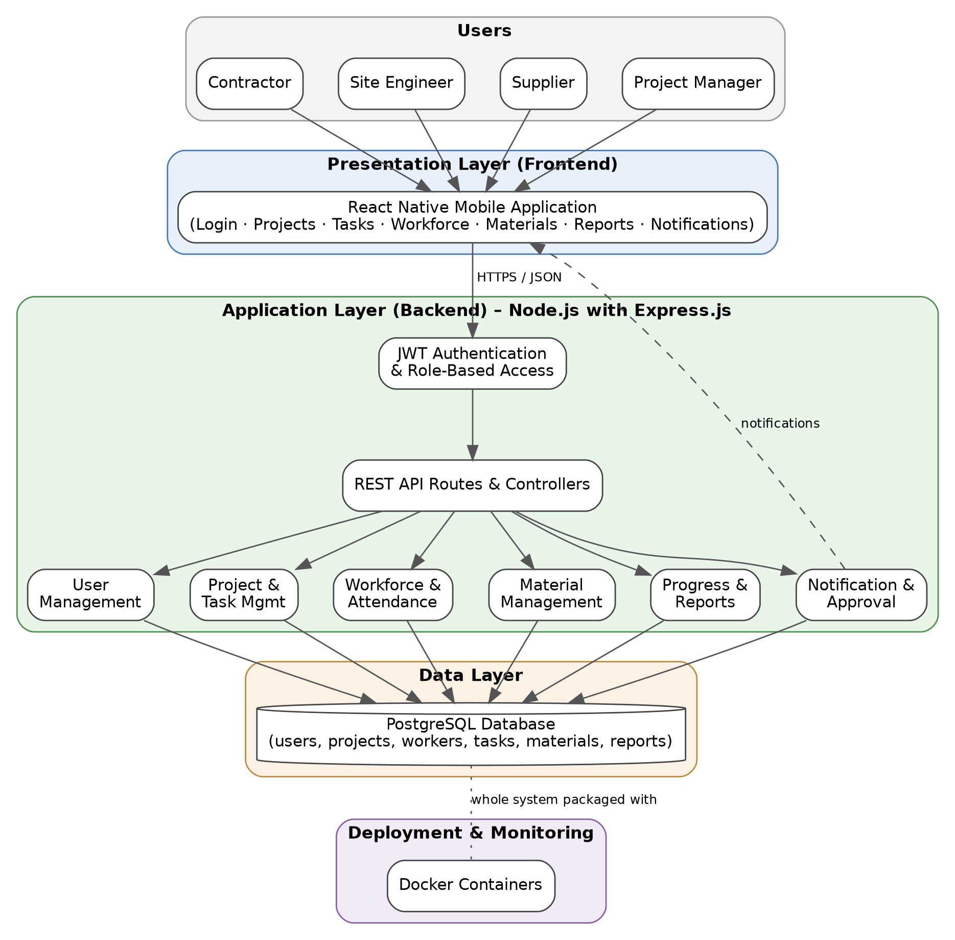
Figure 4.1: High-level architecture of the Construction Mobile App

4.2 Description of Each Layer (Frontend, Backend, Database)
Presentation layer (frontend)
The presentation layer is the React Native mobile application used by contractors, site engineers, suppliers and project managers. It renders the screens, collects user input, keeps the JWT after login, and sends HTTP requests to the back end. It never accesses the database directly.
Application layer (backend)
The application layer is the Node.js and Express.js server. It first authenticates the request using JWT and checks the role of the user. It then routes the request to the correct module (user, project and task, workforce and attendance, material, progress and report, notification and approval), processes the data and builds the response. All communication between the modules and the database passes through this layer.
Data layer (database)
The data layer is the PostgreSQL database. It stores users, projects, workers, tasks, materials and reports in an organised way, together with the attendance, material requests and notifications that connect them. Only the back end connects to the database.
Deployment and monitoring layer
Docker is used to package the application so that it runs the same way on every machine. Monitoring checks that the application is running properly and reliably.

4.3 Deployment Architecture (Cloud, Local, CI/CD Pipelines)
The application is deployed using Docker. The Node.js back end and the PostgreSQL database each run in their own container, and the containers are started together so that the API can reach the database over the container network. The React Native app runs on the user’s phone (or an emulator) and connects to the API through its base URL.
Component | How it is deployed
React Native mobile app | Installed/run on the user’s mobile device or emulator; connects to the API base URL
Node.js + Express.js API | Docker container built from the project’s Dockerfile
PostgreSQL database | Docker container with persistent storage for data
Source code | Maintained in a Git repository on GitHub
Monitoring | Checking container status, logs and API responses to confirm the app is running reliably
The same containers can run on a local machine during development or on any host that supports Docker, so the deployment is not tied to one cloud provider.

CHAPTER -5 DESIGN

5.1 ER Diagram
The entity-relationship diagram below shows the proposed data model. The tables are derived from the information the system must store (users, projects, workers, tasks, materials and reports) together with the attendance, material requests and notifications needed by the modules.
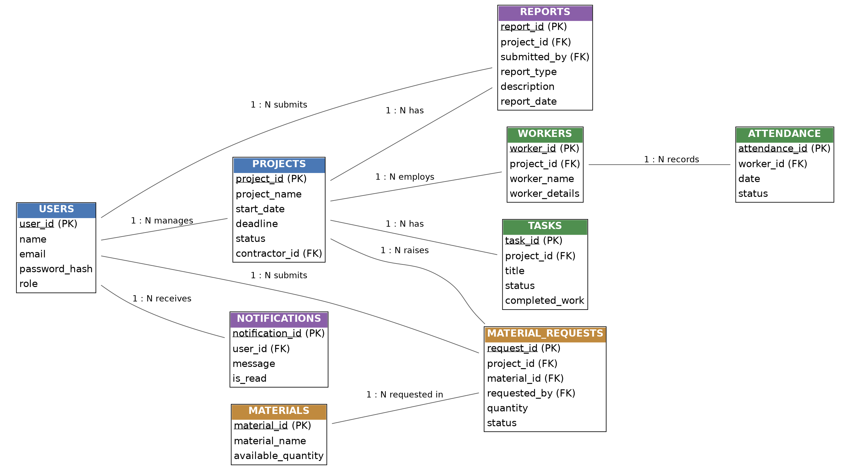
Figure 5.1: ER diagram of the Construction Mobile App

5.2 Database Schema
The proposed relational schema for PostgreSQL is given below. PK denotes a primary key and FK a foreign key.
Relationships in the ER diagram:
- One user (contractor) manages many projects; one project has many tasks, workers, reports and material requests.
- One worker has many attendance records.
- One material can appear in many material requests; one user can submit many material requests and reports.
- One user receives many notifications.
Table: users
Column | Type | Key | Description
user_id | SERIAL | PK | Unique id of the user
name | VARCHAR(100) |  | Name of the user
email | VARCHAR(120) | UNIQUE | Login id of the user
password_hash | VARCHAR(255) |  | Stored (hashed) password
role | VARCHAR(30) |  | Role used for role-based access
Table: projects
Column | Type | Key | Description
project_id | SERIAL | PK | Unique id of the project
project_name | VARCHAR(150) |  | Name of the project
start_date | DATE |  | Project start date
deadline | DATE |  | Project deadline
status | VARCHAR(30) |  | Current status of the project
contractor_id | INT | FK → users | Contractor managing the project
Table: tasks
Column | Type | Key | Description
task_id | SERIAL | PK | Unique id of the task
project_id | INT | FK → projects | Project to which the task belongs
title | VARCHAR(150) |  | Task title
status | VARCHAR(30) |  | Task status
completed_work | TEXT |  | Record of completed work
Table: workers
Column | Type | Key | Description
worker_id | SERIAL | PK | Unique id of the worker
project_id | INT | FK → projects | Project the worker is involved in
worker_name | VARCHAR(100) |  | Name of the worker
worker_details | TEXT |  | Other worker details
Table: attendance
Column | Type | Key | Description
attendance_id | SERIAL | PK | Unique id of the record
worker_id | INT | FK → workers | Worker whose attendance is recorded
date | DATE |  | Date of attendance
status | VARCHAR(20) |  | Present / absent
Table: materials
Column | Type | Key | Description
material_id | SERIAL | PK | Unique id of the material
material_name | VARCHAR(100) |  | Name of the material
available_quantity | INT |  | Quantity currently available
Table: material_requests
Column | Type | Key | Description
request_id | SERIAL | PK | Unique id of the request
project_id | INT | FK → projects | Project requesting the material
material_id | INT | FK → materials | Requested material
requested_by | INT | FK → users | User who submitted the request
quantity | INT |  | Quantity requested
status | VARCHAR(30) |  | Pending / approved / delivered
Table: reports
Column | Type | Key | Description
report_id | SERIAL | PK | Unique id of the report
project_id | INT | FK → projects | Project the report is about
submitted_by | INT | FK → users | User who submitted the report
report_type | VARCHAR(30) |  | Daily update / progress report
description | TEXT |  | Content of the update or report
report_date | DATE |  | Date of submission
Table: notifications
Column | Type | Key | Description
notification_id | SERIAL | PK | Unique id of the notification
user_id | INT | FK → users | User who receives the notification
message | TEXT |  | Notification text
is_read | BOOLEAN |  | Whether the user has read it

CHAPTER -6 IMPLEMENTATION

6.1 Module-wise Implementation
The project is divided into ten modules. The work is shared among the three team members as shown in the module mapping below.
Module | Assigned roll number | Team member
Module 1 – 4 | 2520030182 | P. Venkata Sri Sai Madhurima (Team Lead)
Module 5 – 7 | 2520030102 | T. Hasini
Module 8 – 10 | 2520030521 | Vishal

Module 1: Contractor & User Management
Handles contractor registration, login, profiles and user roles, and ensures that only authorised users can access the application. Implementation: registration and login routes validate the input, store the user in the users table and, on successful login, issue a JWT that carries the user id and role. The mobile app has registration, login and profile screens.
Module 2: Project Management
Allows contractors to view and manage their assigned construction projects, including project details, deadlines and status. Implementation: project routes return the projects assigned to the logged-in contractor and allow the status to be updated. The app shows a project list and a project detail screen.
Module 3: Task & Work Management
Helps contractors view assigned tasks, update task status and record completed work, which makes work progress easier to monitor. Implementation: task routes list the tasks of a project and update the task status and completed-work fields in the tasks table.
Module 4: Workforce & Attendance Management
Maintains worker details and attendance records so that contractors can track the workers involved in different construction projects. Implementation: worker routes add and list workers; attendance routes record attendance per worker per date and list attendance for a project.
Module 5: Material Management
Allows contractors to check available materials and submit material requests, which can be tracked until they are approved and delivered. Implementation: the materials table holds available quantities; material-request routes create a request with status “Pending” and later update the status through approval and delivery.
Module 6: Progress & Report Management
Contractors can submit daily work updates, project progress and reports, which helps project managers monitor construction activities. Implementation: report routes insert daily updates and progress reports into the reports table and list them by project and date.
Module 7: Notification & Approval
Provides notifications for task updates, material requests, approvals and important project activities. Implementation: when a task is updated, or a request or approval changes state, a record is added to the notifications table for the affected user; the app lists these notifications. Approval routes let an authorised user approve or reject a request.
Module 8: Database Management
Stores all important information such as users, projects, workers, tasks, materials and reports in an organised database. Implementation: the PostgreSQL schema of Chapter 5 is created with primary and foreign keys so that related data stays consistent.
Module 9: Backend API Module
Connects the mobile application with the database. It handles user requests, data processing, authentication and communication between different modules. Implementation: the Express.js application with route files per module, JWT middleware, and database access through SQL queries.
Module 10: Deployment & Monitoring
The application can be deployed using technologies such as Docker and monitored to ensure that it is running properly and reliably. Implementation: a Dockerfile for the API and a Docker Compose file that starts the API and PostgreSQL containers; container status and logs are checked to monitor the application.

6.2 Front-end Logic (UI Rendering, State Management)
The React Native app is built from reusable components arranged into screens: login/registration, projects, tasks, workforce and attendance, materials and requests, reports, and notifications.
- UI rendering: each screen renders data received from the API as lists and forms; simple components such as cards and buttons are reused across screens.
- State management: React state and hooks hold the logged-in user, the JWT, and the data of the current screen. Loading and error states are shown while a request is in progress or when it fails.
- Navigation: the user moves between screens through a navigation menu; screens that need login are shown only after authentication.
- API calls: every request to a protected API attaches the JWT in the Authorization header.

6.3 API Integration
The mobile app and the back end communicate through REST APIs that exchange JSON. The proposed endpoints for each module are listed below.
Module | Method & endpoint | Purpose
1 | POST /api/auth/register | Register a new user
1 | POST /api/auth/login | Login and receive a JWT
1 | GET, PUT /api/users/me | View and update the profile
2 | GET /api/projects, GET /api/projects/:id | List projects and view project details
2 | PUT /api/projects/:id | Update project status
3 | GET /api/projects/:id/tasks | List tasks of a project
3 | PUT /api/tasks/:id | Update task status and completed work
4 | GET, POST /api/workers | List and add workers
4 | POST /api/attendance, GET /api/attendance | Record and view attendance
5 | GET /api/materials | View available materials
5 | POST /api/material-requests, GET /api/material-requests/:id | Submit and track material requests
6 | POST /api/reports, GET /api/reports | Submit and view daily updates and reports
7 | GET /api/notifications | List notifications
7 | PUT /api/material-requests/:id/approval | Approve or reject a request
9/10 | GET /api/health | Check that the API is running (monitoring)

6.4 Authentication and Authorisation
Security is provided by JWT for secure user login and role-based access.
- The user logs in with email and password; the server checks the credentials against the users table.
- If they are valid, the server signs a JWT containing the user id and role and returns it to the app.
- The app stores the token and sends it in the Authorization header of every later request.
- Authentication middleware verifies the token; requests with a missing or invalid token are rejected with status 401.
- Authorisation middleware checks the role in the token against the roles allowed for that route; if the role is not allowed, the request is rejected with status 403.
Because of this, only authorised users can access the application and each user can use only the functions that belong to his or her role (for example, only an authorised role may approve a material request).

CHAPTER 7- FEATURES

7.1 List of Main Features
No. | Feature | Module
1 | Contractor registration, login, profiles and user roles | Module 1
2 | Project details, deadlines, status and project scheduling | Module 2
3 | Task assignment, task status updates and recording completed work | Module 3
4 | Worker details and attendance monitoring | Module 4
5 | Material availability check and material requests with tracking | Module 5
6 | Daily work updates, work progress updates and report submission | Module 6
7 | Notification alerts and approval requests | Module 7
8 | Expense tracking and monitoring of resource utilisation | Modules 2, 5, 6
9 | Document sharing and tracking of project milestones | Modules 2, 6
10 | Real-time access to project data and automated reports | Modules 6, 8, 9
11 | Secure role-based access using JWT | Modules 1, 9

7.2 How Each Feature Works
Registration, login and roles
User perspective: the contractor registers once, logs in with email and password and sees only the functions allowed for his or her role. Technical description: the API stores the user in PostgreSQL, verifies the credentials at login and returns a JWT that is checked on every protected request.
Project management and scheduling
User perspective: the contractor opens a project to see its details, deadline and status, and updates the status as work proceeds. Technical description: project routes read and update the projects table for the logged-in contractor.
Task and work updates
User perspective: the contractor sees assigned tasks, changes a task’s status and records the work completed. Technical description: a PUT request updates the status and completed_work columns of the task, and a notification is created for the interested users.
Workforce and attendance monitoring
User perspective: the contractor maintains the list of workers on each project and marks attendance each day. Technical description: worker and attendance routes insert and query records in the workers and attendance tables.
Material requests
User perspective: the contractor checks which materials are available, submits a request and follows it until it is approved and delivered. Technical description: a request is stored with status “Pending”; its status is updated by the approval route, and each change generates a notification.
Progress updates and reports
User perspective: the contractor submits daily work updates and progress reports without paperwork, and project managers read them to monitor construction activities. Technical description: report routes insert records into the reports table and filter them by project and date, which also supports automated reports.
Notifications and approvals
User perspective: the user receives alerts about task updates, material requests, approvals and other important project activities. Technical description: the Notification & Approval module writes a record to the notifications table whenever such an event occurs, and the app fetches and displays them.
Expense tracking, resource utilisation and milestones
User perspective: the contractor monitors how resources and expenses are being used and tracks the milestones of a project. Technical description: these views are built from the project, task, material and report data stored in the database.
Document sharing
User perspective: project documents can be shared with the engineers, suppliers and managers involved in the project. Technical description: documents are linked to a project or a report and made available through the API to authorised users.

CHAPTER -8 TESTING

8.1 Postman Testing (Frontend/Backend)
Postman is used for testing and validating the REST APIs. The APIs are tested with Postman before they are connected to the mobile app, so that errors in the back end can be found and fixed independently of the front end.
Testing approach:
- Create a Postman collection with one folder per module.
- Send a request to register and log in; copy the returned JWT into the collection’s Authorization setting.
- For every endpoint, send valid input and check the status code and the JSON response.
- Send invalid input, a missing token and a token of a wrong role, and check that the correct error codes (400, 401, 403) are returned.
- Check in PostgreSQL that the data was stored or updated as expected.
On the front-end side, the screens are checked by running the app and verifying that the data shown matches the API response.

8.2 Integration Testing
Integration testing checks that modules work together correctly through the API and the database. The main flows tested are:
ID | Flow | Modules involved
IT-1 | Register → login → view projects → view tasks → update task status → notification generated | 1, 2, 3, 7
IT-2 | Login → check materials → submit material request → approval → request status and notification updated | 1, 5, 7
IT-3 | Login → add worker → mark attendance → submit daily report → report visible to the project manager | 1, 4, 6
IT-4 | Start containers with Docker → API connects to PostgreSQL → health check responds | 8, 9, 10

8.3 Tools Used for Testing
- Postman – for sending API requests and validating responses.
- Visual Studio Code – for running the back end and viewing logs during testing.
- Docker – for starting the same environment (API and database) for every test run.
- Mobile device or emulator – for checking the screens of the React Native app.

8.4 Test Cases and Results
The table below lists the planned test cases. The “Actual result” column is to be filled in after the tests are executed.
ID | Module | Test case | Expected result | Actual result
TC-01 | 1 | Register with valid details | 201 Created; user stored
TC-02 | 1 | Login with valid credentials | 200 OK; JWT returned
TC-03 | 1 | Login with wrong password | 401 Unauthorized
TC-04 | 9 | Call a protected API without a token | 401 Unauthorized
TC-05 | 2 | Get projects with a valid token | 200 OK; list of projects
TC-06 | 3 | Update task status and completed work | 200 OK; task updated
TC-07 | 4 | Mark attendance of a worker | 201 Created; attendance stored
TC-08 | 5 | Submit a material request | 201 Created; status “Pending”
TC-09 | 7 | Approve a material request | 200 OK; status updated; notification created
TC-10 | 7 | Approve with a role that is not allowed | 403 Forbidden
TC-11 | 6 | Submit a daily work update | 201 Created; report stored
TC-12 | 7 | Get notifications | 200 OK; list of notifications
TC-13 | 10 | Call the health endpoint | 200 OK
TC-14 | 10 | Start API and database with Docker Compose | Both containers running

CHAPTER -9 DEPLOYMENT

9.1 Steps to Deploy
The application is deployed using Docker so that it runs consistently on any machine.
- Install Docker on the host machine.
- Clone the project repository from GitHub.
- Create the environment file (.env) with the database and JWT settings described in Section 9.2.
- Build the back-end image using the Dockerfile in the project.
- Start the API and PostgreSQL containers together with Docker Compose.
- Create the database tables using the schema script.
- Verify the deployment: check that both containers are running and that the health endpoint and the login API respond correctly in Postman.
- Set the API base URL in the React Native app and run the app on a device or emulator.

9.2 Environment Configuration
Configuration values are kept in environment variables so that they can be changed without editing the code.
Variable | Purpose
PORT | Port on which the Express.js API listens
DB_HOST, DB_PORT | Host and port of the PostgreSQL database
DB_USER, DB_PASSWORD | Database credentials
DB_NAME | Name of the database
JWT_SECRET | Secret key used to sign and verify JWTs
The .env file must not be uploaded to GitHub, because it contains secrets.

9.3 Hosting of Frontend and Backend
- Backend and database: the API and PostgreSQL run as Docker containers on a Docker-capable host (a local machine during development, or any server for use).
- Frontend: the React Native app runs on the users’ mobile devices and connects to the API through its base URL.
- Monitoring: container status, container logs and the health endpoint are checked to make sure that the application is running properly and reliably.

CHAPTER -10 CHALLENGES & LIMITATIONS

10.1 Issues Faced During Development
The following are the main challenges identified while designing and developing the system. (The team should update this list with the actual issues met during implementation.)
- Serving several kinds of users: contractors, site engineers, suppliers and project managers all use the same data but need different access.
- Keeping data consistent across modules: a change in one module (for example, a material request approval) must be reflected in others (status and notifications).
- Secure access: ensuring that only authorised users can reach the application and each route.
- Connecting the mobile app to the back end: the app, the API and the database have to work together reliably.
- Same environment for all team members: the back end and database must run in the same way on each member’s machine.
- Working in parallel: three members developing ten modules at the same time without overwriting each other’s work.

10.2 Solutions Applied
Challenge | Solution
Different user roles | JWT-based login with role-based access checked in middleware
Data consistency | Relational schema in PostgreSQL with primary and foreign keys; related updates handled together
Secure access | JWT verification on protected routes; 401 and 403 responses for unauthorised requests
Integration of app, API and database | REST APIs tested first with Postman, then connected to the React Native screens
Different environments | Docker containers and environment variables
Parallel development | Git & GitHub with the modules divided among the team members (Modules 1–4, 5–7, 8–10)

10.3 Current Limitations or Known Bugs
- The application needs an internet or network connection to reach the back end, so real-time data is not available without it.
- The scope is limited to the ten modules defined in the problem statement.
- The test results in Section 8.4 are to be completed; known bugs, if any, will be recorded there after testing.

CHAPTER -11 FUTURE ENHANCEMENTS

11.1 Planned Features
The following enhancements can extend the system after the core modules are complete:
- Richer automated reports on progress, attendance, expenses and resource utilisation.
- Better handling of shared documents, such as dedicated document storage.
- Alerts for approaching deadlines and milestones.
- Additional views for site engineers, suppliers and project managers.

11.2 Possible Integrations or Optimizations
- Microservices: splitting the back end into independent services (for example, authentication, materials and notifications) so that each part can be deployed and scaled separately.
- CI/CD: automating build, test and deployment of the Docker images from GitHub (for example, with GitHub Actions).
- Additional storage: using a second database type for documents and other unstructured data alongside PostgreSQL.
- Optimisation: adding database indexes and caching for frequently used queries as the number of users and projects grows.

CHAPTER -12 CONCLUSION

12.1 Summary of the Project
Construction projects are still managed largely through manual records, phone calls and meetings, which leads to delayed communication and poor visibility of progress and resources. The Construction Mobile App for Contractor Self-Service addresses this by giving contractors one mobile application to manage projects, tasks, workers, attendance, materials, reports and notifications.
The system is organised into ten modules and is built with React Native, Node.js with Express.js and PostgreSQL, secured with JWT, tested with Postman, and deployed with Docker. The source code is managed with Git and GitHub, and the modules are divided among the three team members.

12.2 What Was Achieved
The project delivers the following:
- A simple app for contractor self-service.
- Tracking of projects, workers, materials and progress in real time.
- Digital requests, approvals, reports and notifications.
- Improved team communication and reduced paperwork.
- Saved time and more efficient construction work.
(This section should be updated with the final status of each module and test results when the project is complete.)

12.3 Skills Learned During Development
- Designing a relational database in PostgreSQL with keys and relationships.
- Building REST APIs with Node.js and Express.js.
- Implementing JWT authentication and role-based access control.
- Developing a mobile user interface with React Native.
- Testing APIs with Postman.
- Packaging and deploying an application with Docker.
- Using Git and GitHub for collaboration, and dividing work among team members.

CHAPTER -13 REFERENCES
Documentation and Research Resources
- React Native Documentation. Retrieved from https://reactnative.dev/docs/getting-started
- Node.js Documentation. Retrieved from https://nodejs.org/en/docs
- Express.js Documentation. Retrieved from https://expressjs.com
- PostgreSQL Documentation. Retrieved from https://www.postgresql.org/docs/
- JSON Web Tokens – Introduction. Retrieved from https://jwt.io/introduction
- Jones, M., Bradley, J., Sakimura, N. (2015). JSON Web Token (JWT), RFC 7519. Retrieved from https://www.rfc-editor.org/rfc/rfc7519
- Postman Learning Center. Retrieved from https://learning.postman.com
- Docker Documentation. Retrieved from https://docs.docker.com
- Git Documentation. Retrieved from https://git-scm.com/doc
- GitHub Docs. Retrieved from https://docs.github.com
- Visual Studio Code Documentation. Retrieved from https://code.visualstudio.com/docs

CHAPTER -14 APPENDICES

A. Screenshots of the App
Insert the screenshots below after the screens are implemented.
No. | Screen | Screenshot
1 | Registration / Login | [Insert screenshot]
2 | Project list and project details | [Insert screenshot]
3 | Task list and task update | [Insert screenshot]
4 | Workers and attendance | [Insert screenshot]
5 | Materials and material requests | [Insert screenshot]
6 | Daily update / progress report | [Insert screenshot]
7 | Notifications and approvals | [Insert screenshot]
8 | Postman test results | [Insert screenshot]
9 | Docker containers running | [Insert screenshot]

B. Sample Code Snippets
1. SQL – creating the main tables (PostgreSQL)
CREATE TABLE users (
user_id SERIAL PRIMARY KEY,
name VARCHAR(100) NOT NULL,
email VARCHAR(120) UNIQUE NOT NULL,
password_hash VARCHAR(255) NOT NULL,
role VARCHAR(30) NOT NULL
);

CREATE TABLE projects (
project_id SERIAL PRIMARY KEY,
project_name VARCHAR(150) NOT NULL,
start_date DATE,
deadline DATE,
status VARCHAR(30) DEFAULT 'Planned',
contractor_id INT REFERENCES users(user_id)
);

CREATE TABLE tasks (
task_id SERIAL PRIMARY KEY,
project_id INT REFERENCES projects(project_id),
title VARCHAR(150) NOT NULL,
status VARCHAR(30) DEFAULT 'Assigned',
completed_work TEXT
);

2. Node.js – JWT authentication and role check (Express.js)
const jwt = require('jsonwebtoken');

function authenticate(req, res, next) {
const header = req.headers.authorization || '';
const token = header.startsWith('Bearer ') ? header.slice(7) : null;
if (!token) return res.status(401).json({ message: 'Token missing' });
try {
req.user = jwt.verify(token, process.env.JWT_SECRET);
next();
} catch (err) {
res.status(401).json({ message: 'Invalid or expired token' });
}
}

function authorize(...roles) {
return (req, res, next) =>
roles.includes(req.user.role)
? next()
: res.status(403).json({ message: 'Access denied' });
}

3. Dockerfile for the API
FROM node:20-alpine
WORKDIR /app
COPY package*.json ./
RUN npm install --omit=dev
COPY . .
EXPOSE 3000
CMD ["node", "server.js"]

4. docker-compose.yml
services:
db:
image: postgres:16
environment:
POSTGRES_USER: ${DB_USER}
POSTGRES_PASSWORD: ${DB_PASSWORD}
POSTGRES_DB: ${DB_NAME}
volumes:
- dbdata:/var/lib/postgresql/data
api:
build: .
ports:
- "3000:3000"
env_file: .env
depends_on:
- db
volumes:
dbdata:

C. Installation / Setup Instructions
- Install Node.js, Git, Docker and Visual Studio Code. Install Postman for API testing.
- Clone the repository from GitHub and open it in Visual Studio Code.
- Create the .env file with PORT, DB_HOST, DB_PORT, DB_USER, DB_PASSWORD, DB_NAME and JWT_SECRET.
- Run docker compose up --build to start the API and PostgreSQL containers.
- Create the tables using the SQL script.
- In the mobile app folder, run npm install and start the React Native app on a device or emulator.
- Set the API base URL in the app to the address of the running API.

D. User Manual / Guide
Task | Steps
Register and log in | Open the app → tap Register → enter details → log in with email and password.
View projects | Open Projects → select a project to see its details, deadline and status.
Update a task | Open the project → Tasks → select a task → change the status and enter the completed work → Save.
Mark attendance | Open Workforce → select the project → mark each worker present or absent → Submit.
Request material | Open Materials → check availability → Request → enter quantity → Submit; track the status in the same screen.
Submit a report | Open Reports → choose daily update or progress report → enter details → Submit.
Check notifications | Open Notifications to see task updates, request status and approvals.

E. Geo Tag Photos with Guide
[Insert geo-tagged photos of the team with the guide here.]

F. Review Forms with Guide Signatures
[Attach the Project Problem Statement Submission Form (Team No. 9, Section 3) and the review forms signed by the guide here.]

